**BEEE LAB FILE**

EXP1: DESIGN DUAL LED CHASER

Circuit diagram:

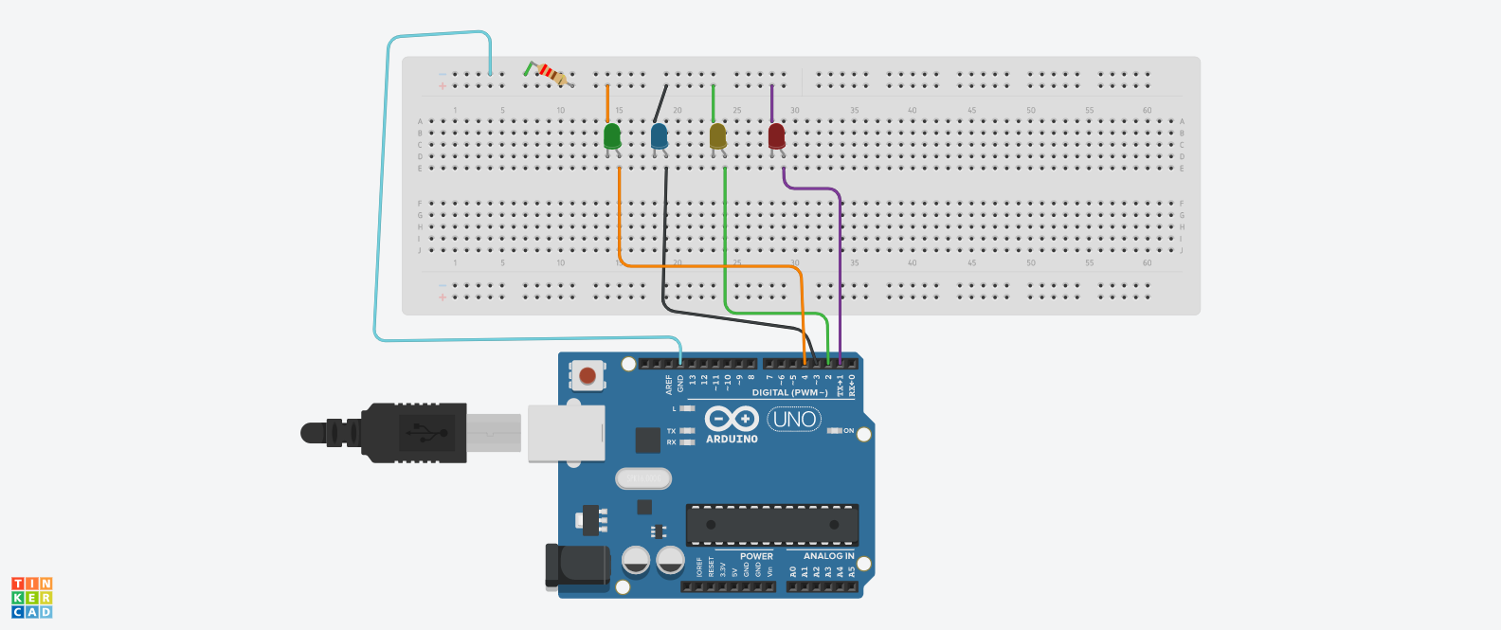

**THEORY**

**CONCEPTS USED:**

1. The use of ARDUINO board and ARDUINO IDE.
2. Connection of multiple LED'S to RDUINO board.
3. Use of Ohm's law to calculate value of appropriate resistance for LED.
4. Concept of LED flashing learnt previously.
5. Use of if-else statements
6. Use of loops.

**LEARNING AND OBSERVATIONS:**

1. Not using a resistance can damage the LED.
2. A proper amount of delay needs to be given between blinking of LED'S so human eyes can see them.
3. Any discrepancy in the circuit will lead to the circuit not working.
4. Learnt about the use of if- else in coding.
5. Improper connections can lead to circuit breakage.
6. Speed of the blinking of LED'S decreases as we increase the amount of delay.
7. The LED needs to be in forward bias.
8. For loop helps optimize the code.

**PROBLEMS AND TROUBLESHOOTING:**

1. The blinking of LED'S was too fast and thus the problem was solved by increasing the delay.
2. The previous LED was not getting off and I realized I had forgotten to write the code for it to go off.
3. One LED would still not glow and after inspection and observation, it was found that the LED was broken. So the problem was resolved by taking a new LED.
4. The circuit was incomplete as there was a wrong connection to the ground pin. This was solved by correcting the circuit.
5. The LED would not glow and then I figured out that the value of resistance was too high, so I used a new resistor of 220 ohm which is a desired value.

**PRECAUTIONS:**

1. Make sure to use a resistance of appropriate value.
2. All LED's should be connected in forward bias only.
3. Make sure that the equipment being used it dry and is in no proximity of water.
4. Make sure the connections are appropriate and there is no unnecessary connection.
5. Make sure the arduino board is not corrupted.
6. Make sure loop is enclosed in parenthesis.

**LEARNING OUTCOMES:**

1. I can now design LED chaser lights.
2. Loops are very useful as they optimize the circuit.
3. I now know how to optimize circuits as I got to learn that one resistance was enough for the entire circuit because at one time only two LED's had to glow.
4. I learnt about proper connection of circuits and how to connect them.
5. I know about the coding of dual led chaser lights and the use of if-else in coding.
6. I now have appropriate Knowledge about the ARDUINO ports and components and optimization.
7. Now I have enhanced and improved knowledge of breadboard connections.